FINAL REPORT | DATA ANALYST INTERNSHIP
Comprehensive Reporting and Strategic Recommendation
Where should a virtual food processor focus, and how should it work with data? Evidence from Project FOODFLOW
Prepared by: Ayush Yadav
Date: 29 October 2026
Scenario: NutriLine Foods, a virtual food processing company
Primary tool: Microsoft Excel (formulas, PivotTables, VBA, dashboards)
4  Weeks of work combined into one report | 6  Strategic recommendations | 11,028  Rows of FAO data analysed in Excel | 5  Groups of advanced Excel techniques

How to read this report
Numbers marked real come from FAO data or published statistics. Numbers marked illustrative are worked examples from the Week 1 plan (for instance, the efficiency index and the dollar values) that show how the method works, and they are not findings. The report keeps the two apart throughout.

Executive Summary
The question. NutriLine Foods is a virtual food processing company. Where should it focus its products and capacity, and how should it work with data so that its decisions are fast, accurate, and repeatable?
The approach. Over four weeks, the project planned an analysis (Week 1), cleaned and summarised 11,028 rows of FAO food supply data with PivotTables (Week 2), automated a screening report with advanced formulas and a VBA macro (Week 3), and built an interactive dashboard (Week 4). This report brings that work together and turns it into recommendations.

What the data shows
- Meat demand is rising, and the mix is changing. Average meat supply per person rose 77% between 1961 and 2017 (27.6 to 48.7 kg). Poultry grew from 9.8% to 41.3% of the meat supply and overtook beef.
- Markets are very unequal. In 2017, Hong Kong had 137.1 kg of meat per person and India 3.8 kg, about 36 times less. Afghanistan fell from 52% of the country average in 1961 to 18% in 2017.
- Food security has improved a great deal, but problems remain. The share of countries below 2,100 kcal per person per day fell from 45.2% in 1961 to 4.7% in 2017. Eight countries are still flagged, and 33 more are on a watch list.
- Growing markets move fast. Algeria's milk supply tripled between 1964 and 2017, and Brazil's poultry supply rose about 28 times.

What we recommend
# | Recommendation | Priority
R1 | Prioritise poultry processing capacity. | High, after checking with plant and price data
R2 | Build a shelf-stable dairy offer for markets that are moving out of food scarcity. | High
R3 | Sort markets into three tiers and set targets by market, not by the global average. | Start now
R4 | Run the annual early-warning list and plan affordable, fortified products for flagged markets. | Start now
R5 | Make data-quality checks and automation standard practice. | Start now
R6 | Collect plant-level data to measure real efficiency (yield, energy, labour). | Begin now, ongoing

An important limit. The FAO data describes food supply and demand, not what happens inside a factory. The recommendations therefore concern where to focus and how to work with data. Recommendation R6 explains how to close the gap with real plant data.

1. Introduction and Background

1.1 The scenario
Virtual food processing means studying and improving the food-processing chain (raw ingredients to packed products) through data and simulation instead of on a real factory floor. The project models a fictional mid-sized plant, NutriLine Foods, and benchmarks it against real public data. This lets a team test ideas in a spreadsheet before any money or machinery is involved.

1.2 Why data-driven decisions matter in food processing
- Thin margins. Small gains in yield or energy use matter a great deal.
- Volatile inputs. Crop yields, weather, and prices swing from year to year.
- Perishability and safety. Waste and errors are costly, so problems should be caught early.
- Changing demand. What people eat is shifting, and capacity takes years to build.

1.3 Industry context (real, published figures)
Indicator | Figure
US food manufacturing, 2019 | 7.6% of manufacturing jobs but 9.1% of value added, about 1.2 times the manufacturing average per worker (US Census Bureau).
US food manufacturing jobs | 1,477.8 thousand (2010) to 1,554.1 thousand (2015), +5.2% (US Bureau of Labor Statistics).
India, food products, 2023-24 | 11.06% of registered factory workers, about 21.6 lakh people (MoSPI Annual Survey of Industries, as reported).
Data revision example | FAO's 2025 world cereal forecast was revised by +3.8% between briefs, a reminder that published figures change.

1.4 Objectives
The project set five objectives in Week 1: (O1) consolidate public data into one documented Excel model, (O2) quantify trends, (O3) build a Production Efficiency Index, (O4) test hypotheses, and (O5) deliver a dashboard and evidence-backed recommendations. This report completes O5 and draws the other work together.

1.5 The four-week journey
Week | Task | Main output | Feeds this report as
1 | Analysis strategy and planning | Project FOODFLOW plan: objectives, six research questions, four hypotheses, five data sources, a 33-hour timeline and a risk register. | Background and methodology
2 | Data transformation and pivot tables | A cleaned table of 11,028 rows, nine logged cleaning decisions and four PivotTables. | Core findings
3 | Advanced functions and automation | Formulas (nested IF, SUMPRODUCT, INDEX/MATCH) and a VBA macro that builds a screening report. | Technique detail and the early-warning list
4 | Dashboard and visualisation | An interactive dashboard with three dropdowns, five KPI cards and three charts. | Visuals and market comparisons
5 | Reporting and recommendations | This report. | The conclusion

2. Methodology

2.1 Data sources
Source | Role in the project | Status
FAO Food Balance Sheets (via Our World in Data) | Food supply per person for 216 countries, regions and groups, 1961 to 2017: calories, protein, meat by type, milk, fruit, vegetables. | Used for all analysis in Weeks 2 to 4. Real data.
Diet compositions by commodity (FAO via Our World in Data) | Calories by food group, used to compare staples with perishable foods (Week 1 pilot). | Used for the Week 1 hypothesis pilot. Real data.
US Census ASM, India ASI, Eurostat, Open Food Facts | Plant-level and industry measures: labour, capital, energy, product mix. | Planned for the efficiency index. Used only as published context here (Section 1.3).

2.2 The FOODFLOW analysis line
The Week 1 plan treated the analysis like a processing line with five stations: Intake (collect data), Inspect (quality checks), Process (transform and model), Package (charts and dashboard), and Dispatch (recommendations). The weeks map onto it directly: Week 2 covered Intake, Inspect, and Process; Week 3 automated Inspect and Process; Week 4 was Package; and this report is Dispatch.

2.3 Data cleaning and quality controls
The FAO file was imported untouched into a Raw_Data sheet and cleaned in a copy. Nine issues were found and logged. The most important decisions were:
Issue | Decision
34 regions or groups and 8 former states mixed with countries (2,051 rows, 18.6%) | Classified every entity with an INDEX/MATCH lookup (Type column) and kept Country rows only for averages, ranks and top 10 lists, so nothing is counted twice. 8,977 rows (174 countries) were analysed.
276 blank pigmeat values | Left blank and flagged "Not reported", because pork is not part of the supply in those places. Zero or an average would have invented data.
Meat total against its five parts | Added a check column. The largest difference is 0.16 kg (rounding), so every row passes.
Uneven coverage (146 countries in 1961, 172 in 2017) | Kept as is, and tested trends on a balanced panel of 144 countries, which gave the same result.

2.4 Advanced Excel techniques used
Week | Techniques | What they were used for
1 | Min-max normalisation, weighted formulas, CORREL, SLOPE, RSQ, T.DIST.2T, lagged correlation, Data Tables, Goal Seek, FORECAST.ETS (planned) | Planning the efficiency index and hypothesis tests, with worked examples of each.
2 | Excel Tables and structured references; INDEX/MATCH; IF; ROUND and SUM; PivotTables, PivotCharts, Value Field Settings, Top 10 filters and Show Values As | Cleaning, classifying and validating the data, then summarising it four ways.
3 | Nested IF; SUMPRODUCT with several conditions; INDEX/MATCH with MAX and MAXIFS; VBA macro (loops, conditions, error handling) | Grading every row, averaging a filtered group, and building the early-warning report in one click.
4 | Named ranges; Data Validation dropdowns; helper columns that switch metrics with INDEX/MATCH; SUMIFS, AVERAGEIFS, COUNTIFS; LARGE; NA(); line, bar and doughnut charts; conditional formatting; a linked text box | The interactive dashboard and its self-writing Key Insights panel.
All | Independent recalculation, built-in cross-checks and scenario tests | Proving that the results can be trusted (Section 2.5).

2.5 Validation
- Independent recalculation. Results were rebuilt separately from the table data and compared with Excel: all 11,028 nutritional grades matched, the eight-country macro list matched exactly, and the dashboard's KPIs, top 10, and meat mix matched.
- Built-in cross-checks. The dashboard calculates value, average, variance, and rank two ways (SUMIFS/COUNTIFS and FILTER/XLOOKUP), and both give the same answers.
- Scenario tests. Weeks 3 and 4 documented test cases with expected values (for example, Brazil poultry in 2017: 48.03 kg, rank 11 of 172).
- A check that caught a problem. A "highest calories" lookup returned a former territory (Netherlands Antilles, 1984) instead of the highest current country in 2017 (Belgium, 3,768 kcal). The scope was refined.

3. Analysis and Findings

3.1 Demand is rising, and the mix is shifting towards poultry
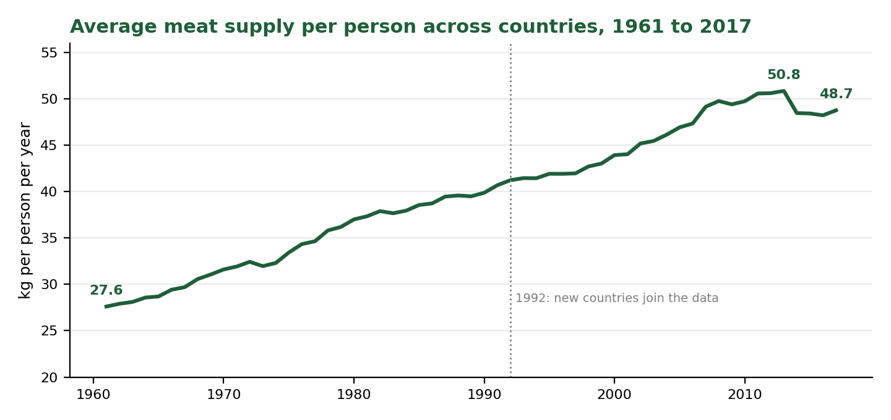
Figure 1. Average meat supply per person across countries (real FAO data).
Average meat supply rose from 27.6 kg to 48.7 kg per person between 1961 and 2017, a rise of 77%, or about 1% a year. The country list changes in 1992, so the trend was re-tested on the 144 countries present every year, and the same 1.77-fold rise appeared. The yearly change is steady (a standard deviation of 1.3 percentage points). The largest fall, 4.7% in 2014, coincides with two countries leaving the data, so it should be treated with caution.
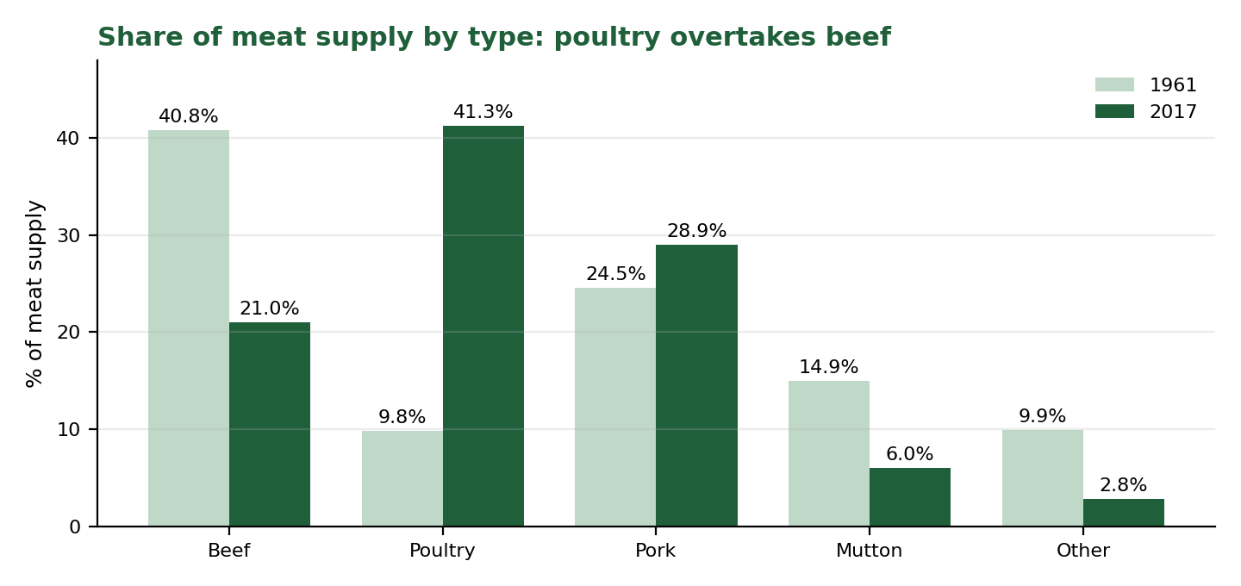
Figure 2. Share of meat supply by type, 1961 and 2017 (real FAO data).
The change in the mix is larger than the change in the total. Poultry grew about 7.4 times (2.7 to 20.2 kg) and rose from 9.8% to 41.3% of meat supply, overtaking beef, which fell from 40.8% to 21.0%. Pork roughly doubled in volume. Mutton and other meat declined.
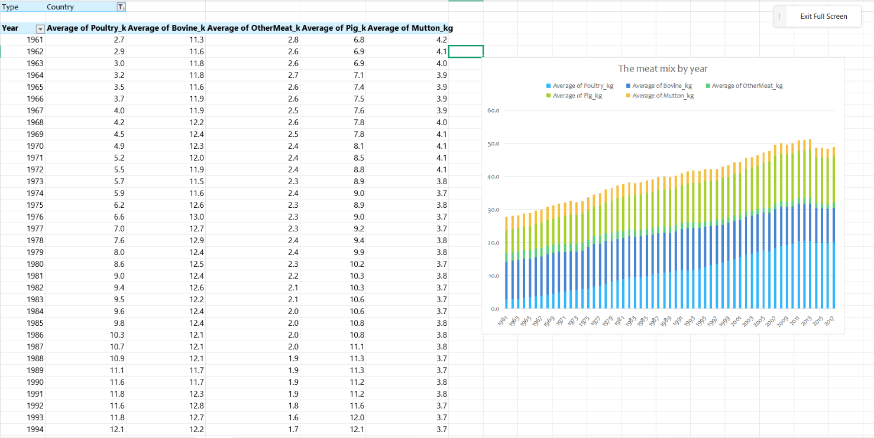
PivotTable of the meat mix by year (Week 2, Pivot_2) with its stacked column chart
Figure 3. The Week 2 PivotTable behind Figures 1 and 2.

3.2 Markets are very unequal
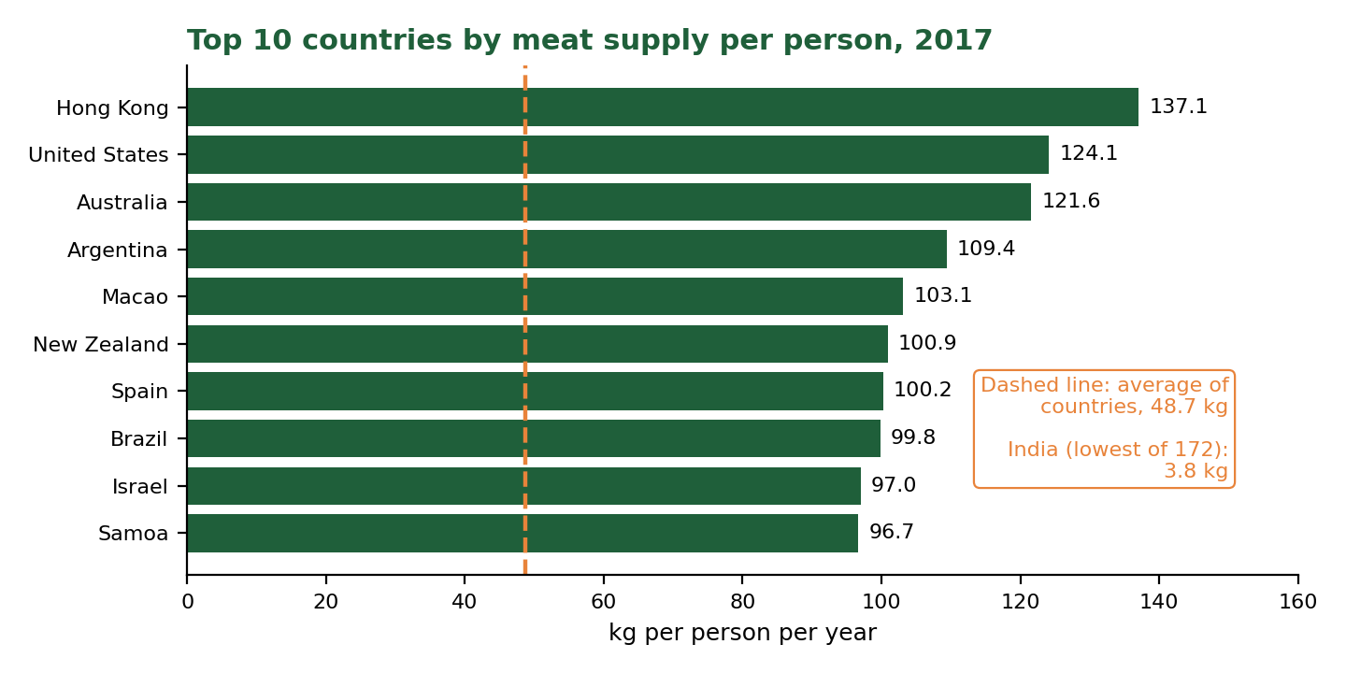
Figure 4. Top 10 countries by meat supply per person, 2017 (real FAO data).
Measure (2017) | Value | What it tells us
Highest: Hong Kong | 137.1 kg | Followed by the United States (124.1) and Australia (121.6).
Average of 172 countries | 48.7 kg | The median is 45.4 kg, so a few high values pull the average up.
Lowest: India | 3.8 kg | About 36 times lower than Hong Kong. Bangladesh is 4.0 and Ethiopia 5.4.
India, milk instead | 106.1 kg | Above the country average (+4.7%) and rank 67 of 172, so low meat does not mean low protein.

Gaps also widen within a country's own history. Afghanistan had 14.5 kg of meat per person in 1961 (52% of the country average of 27.6 kg) but 8.6 kg in 2017 (18% of an average that had grown to 48.7 kg). Its supply fell 41% while the average rose 77%.

3.3 Food security has improved greatly, but is concentrated
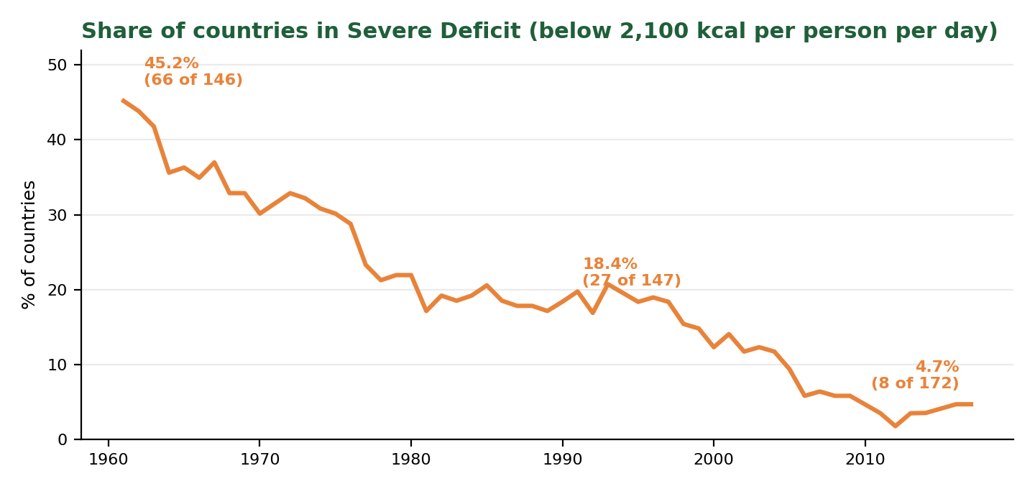
Figure 5. Share of countries below 2,100 kcal per person per day (real FAO data, screening threshold).
Using the Week 3 screening rule (below 2,100 kcal is Severe Deficit, below 2,500 is Warning), the share of countries in Severe Deficit fell from 45.2% (66 of 146) in 1961 to 18.4% (27 of 147) in 1990 and 4.7% (8 of 172) in 2017. The Week 3 macro lists the eight remaining countries:
# | Country (2017) | Calories (kcal) | Protein (g) | Status
1 | Central African Republic | 1,758 | 46.4 | Severe Deficit
2 | Madagascar | 1,903 | 42.9 | Severe Deficit
3 | Afghanistan | 2,000 | 54.1 | Severe Deficit
4 | Zambia | 2,013 | 59.1 | Severe Deficit
5 | North Korea | 2,032 | 52.3 | Severe Deficit
6 | Bahamas | 2,043 | 61.5 | Severe Deficit
7 | Yemen | 2,063 | 53.2 | Severe Deficit
8 | Chad | 2,090 | 70.5 | Severe Deficit

- Their average protein supply is 55.0 g against 81.3 g across all countries, so calories and protein fall short together.
- 33 more countries are in Warning. The closest to the line are Tajikistan (2,104 kcal) and Kenya (2,124).
- The list depends on the threshold: 2 countries fall below 2,000 kcal, 8 below 2,100, and 15 below 2,200. The threshold is a decision, not a fact.
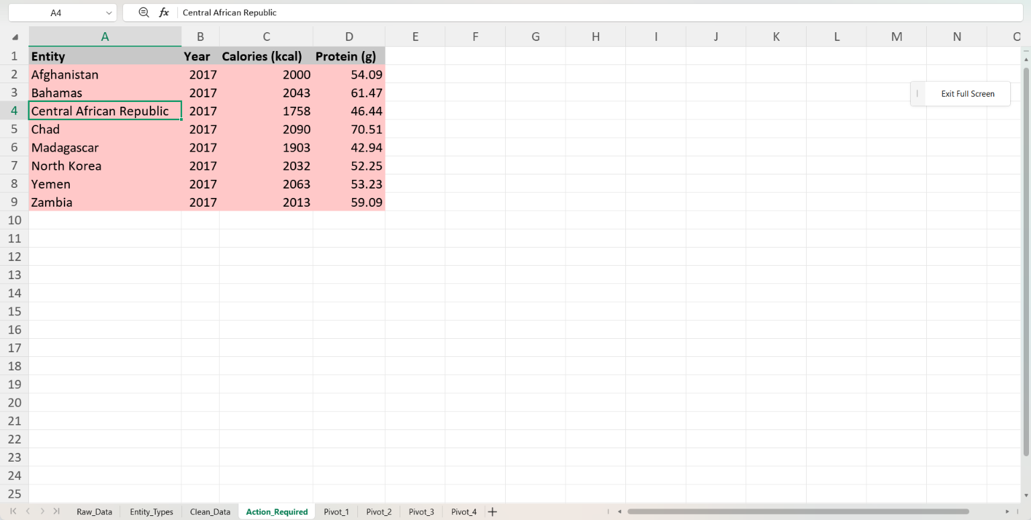
The Action_Required sheet produced by the Week 3 macro
Figure 6. The macro-generated early-warning list.

3.4 Growing markets move fast: dairy and poultry examples
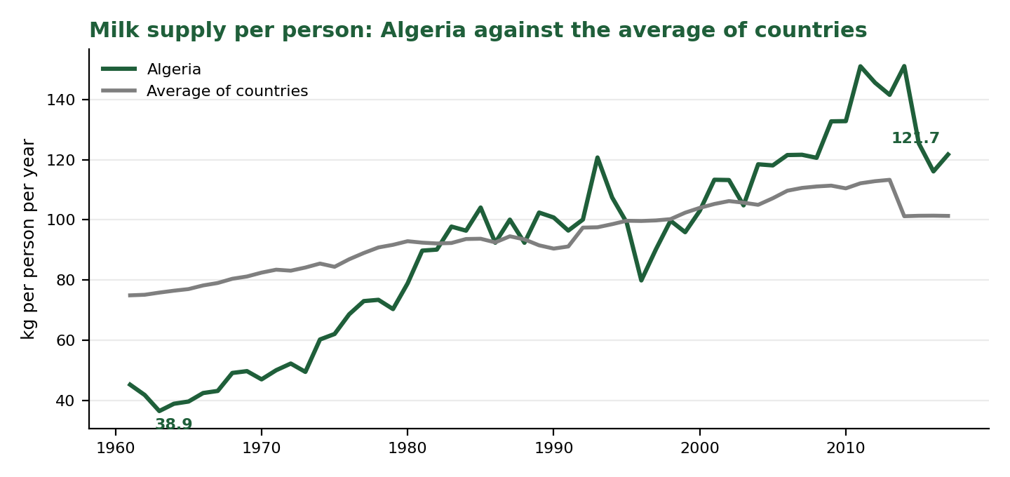
Figure 7. Algeria: milk supply per person against the average of countries (real FAO data).
Algeria raised its milk supply from 38.9 kg in 1964 to 121.7 kg in 2017, about 3.1 times. It moved from 49% below the country average to 20% above it, its rank improved from 86th of 146 to 57th of 172, and its calorie status moved from Severe Deficit (1,540 kcal) to Adequate (3,349 kcal).
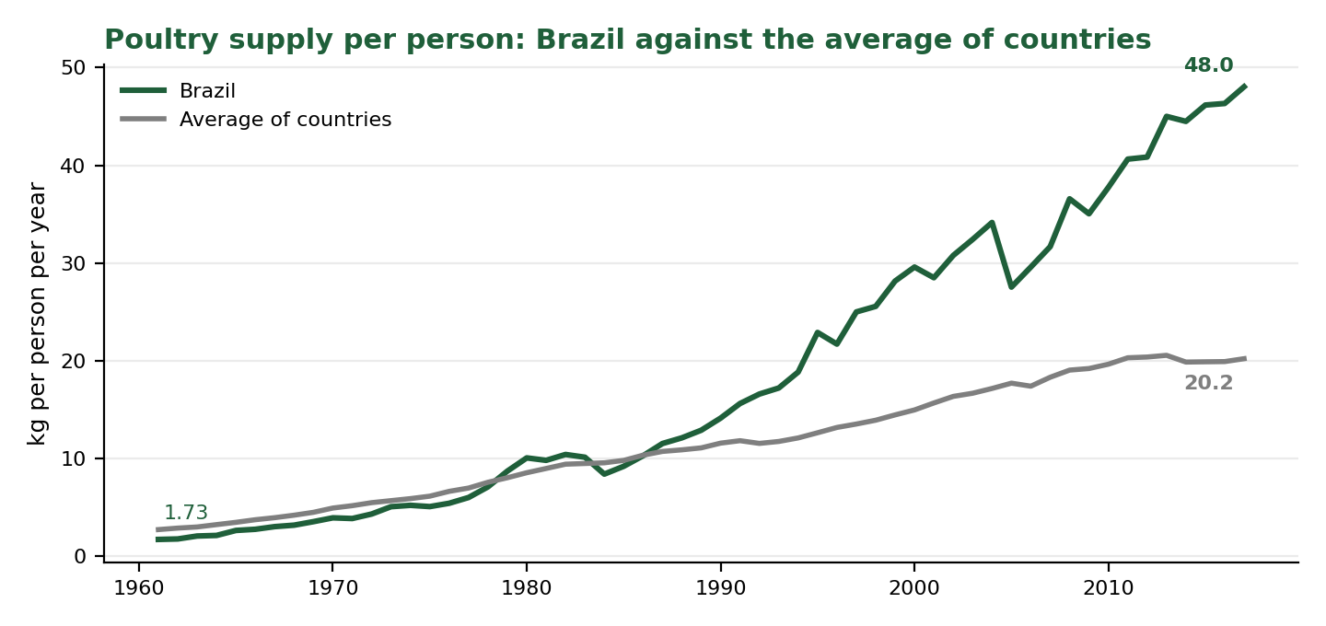
Figure 8. Brazil: poultry supply per person against the average of countries (real FAO data).
Brazil raised its poultry supply from 1.73 kg to 48.03 kg, about 28 times, and rose from 69th of 146 countries to 11th of 172. The average of all countries grew 7.4 times (2.74 to 20.22 kg), so Brazil moved from below the average to well above it.

3.5 Planning-stage results from Week 1
The Week 1 plan set hypotheses and built a method for measuring plant efficiency. Only one hypothesis could be tested on real data in the time available; the others were worked through on illustrative data to prove the method.
Item | What was tested | Data | Result
H4 | Staples (cereals) are steadier than perishables | Real FAO data, 142 countries | Partly supported. Perishables were more volatile in 77% to 85% of countries, but the median ratio (1.3 to 2.0) fell short of the 2x rule.
H1 | Capital-intensive segments produce more per worker | Illustrative | Supported (r = 0.957). Method proven.
H2 | Raw-material price rises squeeze margins after a delay | Illustrative | Supported at a one-year lag (r = -0.795). Method proven.
H3 | Energy-hungry segments score lower on efficiency | Illustrative, 6 points | Not supported: six points cannot separate the signal from chance.
PEI | Production Efficiency Index for NutriLine Foods | Illustrative | Ranked 4th of 6 under all five weight sets (0.264 in the base case).

The illustrative lever analysis also showed why a ranking alone is not enough: energy was NutriLine's weakest component, but raising yield by 3 points was worth about 12 times as much as a 10% energy saving (illustrative: $540,000 against $46,000 a year, under stated assumptions). This is the reason recommendation R6 asks for real plant data.

3.6 What the data cannot tell us
- It measures food supply per person, not food eaten or factory output.
- "Average of countries" gives every country equal weight, whatever its size, and "rank" is among the 146 to 172 countries with data that year.
- It contains no prices, costs, energy use, or yields, so it cannot measure plant efficiency directly.
- It stops in 2017.

4. Visualisation: The Interactive Dashboard
The dashboard gives managers the same findings without any formulas. A user picks a country, a year,r and a metric from three dropdowns, and the whole screen updates:
Component | What it shows
Five KPI cards | Metric value, country average, difference from average (red below, green above), rank among countries, and a traffic-light nutritional status.
Line chart | The selected country against the average of all countries, 1961 to 2017.
Bar chart | The top 10 countries for the chosen metric and year.
Doughnut chart | The meat mix (beef, poultry, pork, mutton, other) for the selected country and year.
Key Insights box | Three sentences, written by formulas, that describe the current selection in plain language.

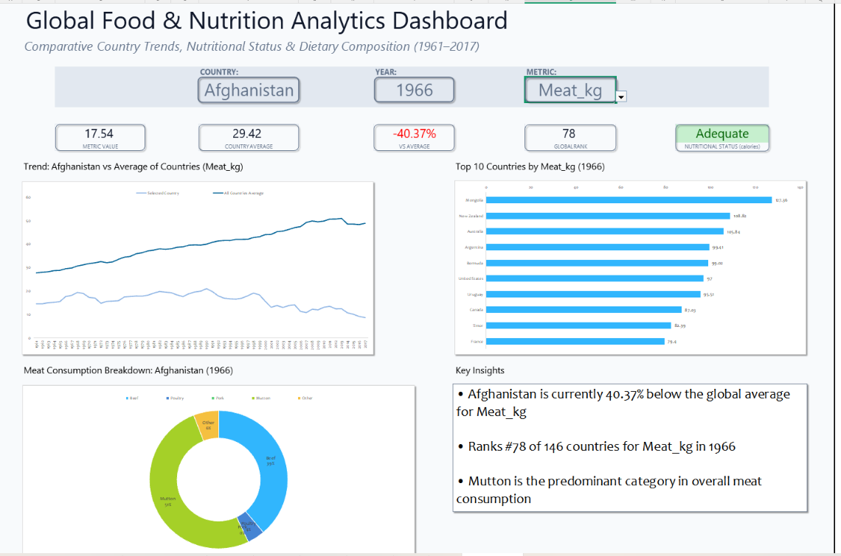
Dashboard: Afghanistan, 1966, Meat_kg (the saved view)
Figure 9. The dashboard, default view.
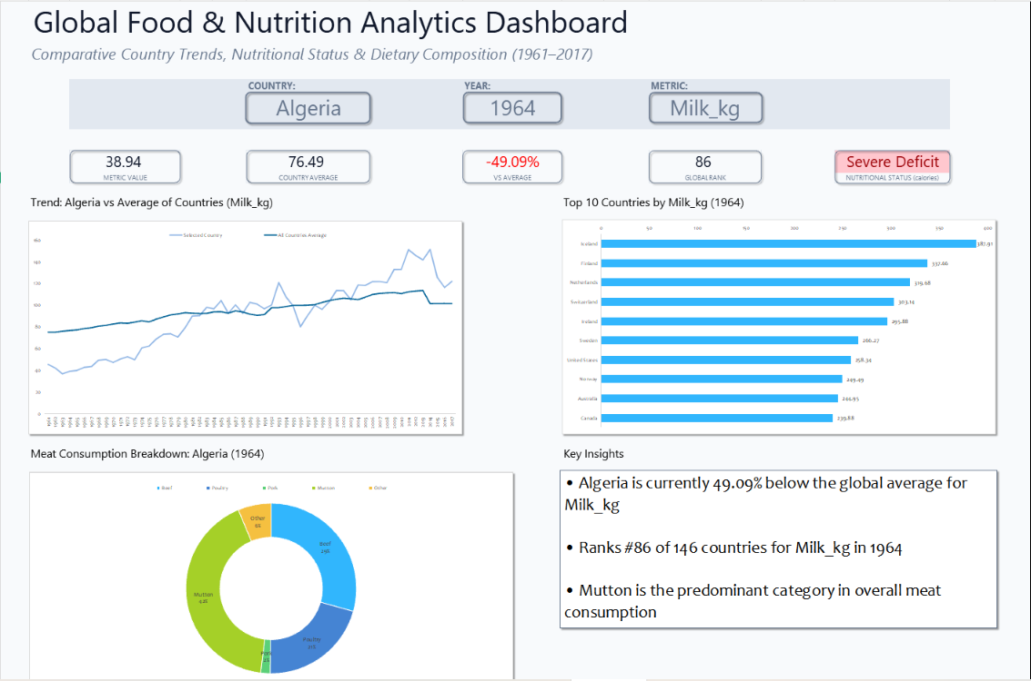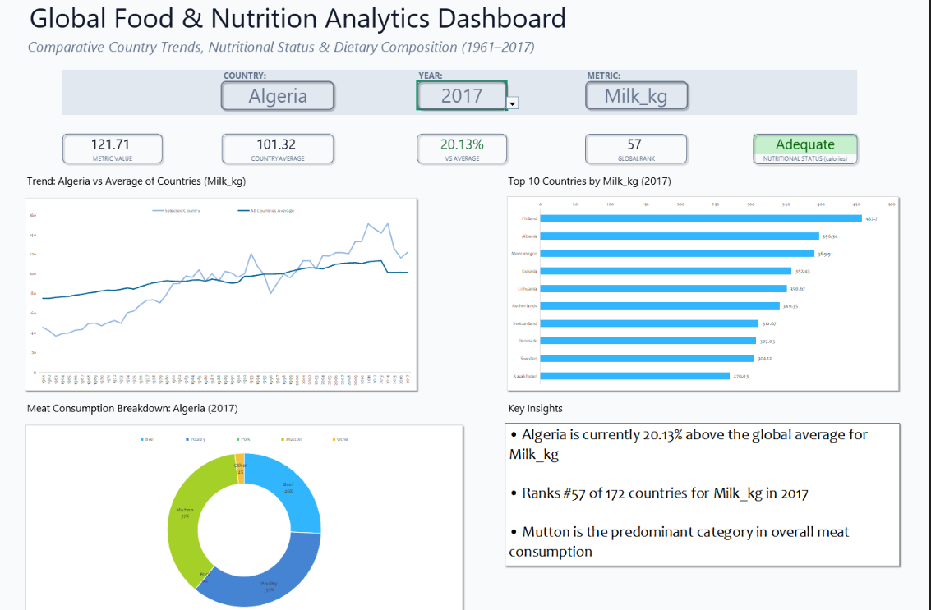
Dashboard: Algeria, 1964 or 2017, Milk_kg
Figure 10. The dashboard, a market moving out of deficit.
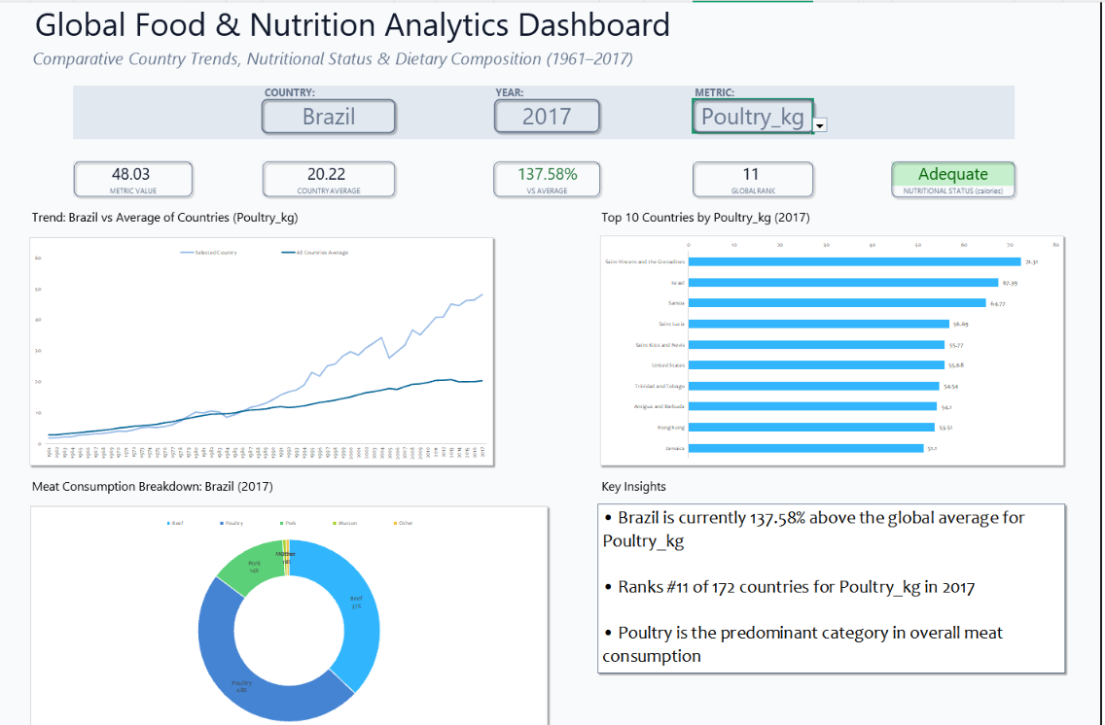
Dashboard: Brazil, 2017, Poultry_kg
Figure 11. The dashboard, the fastest-growing meat.

How a manager uses it
- Choose a market and a year.
- Read the five cards: is this market above or below average, and how does it rank?
- Check the trend line to see whether the gap is widening or closing.
- Switch the metric (for example from meat to milk) to see whether the market's needs differ.
- Read the Key Insights box for a plain-language summary to paste into a meeting note.

5. Interpretation: Quality, Efficiency and Cost
The brief asks for the results to be read in terms of production quality, efficiency and cost management. The table separates what the analysis supports from what still needs plant data.
Theme | What the analysis shows | What it means for NutriLine Foods | Related
Quality | Markets sit in clear tiers: 3,768 kcal a day in Belgium against 1,758 in the Central African Republic. Quality checks on the data itself (classification, flags, cross-checks) caught double counting and a scope error before they reached a decision. | Match the product to the market: variety and quality in high-supply markets, affordable fortified products in low-supply ones. Trust results only after they pass the checks. | R3, R4, R5
Efficiency | Demand is concentrating in poultry (9.8% to 41.3% of meat). One macro run replaces a manual filter, copy and format routine, and the dashboard answers a market question in seconds. | Point capacity at the fastest-growing lines, and automate recurring reports. Real plant efficiency still needs plant data. | R1, R5, R6
Cost | Demand differs sharply by market (Hong Kong 137.1 kg against India 3.8 kg of meat). The illustrative lever analysis suggests a yield gain can be worth far more than an energy saving. | Avoid building capacity where demand is weak, and test improvements by value before choosing them. The size of any saving has to be measured with real prices and costs. | R1, R3, R6

6. Strategic Recommendations
The six recommendations below follow one pattern: the finding, the recommendation, the expected benefit and how to track it, how advanced Excel analysis shaped it, and a caution.

6.1 Overview
# | Recommendation | Theme | Priority
R1 | Prioritise poultry processing capacity | Efficiency, cost | High
R2 | Build a shelf-stable dairy offering for markets experiencing scarcity | Quality, cost | High
R3 | Sort markets into three tiers and set targets by market | Quality, cost | Start now
R4 | Run the annual early-warning list | Quality | Start now
R5 | Make data-quality checks and automation standard practice | Quality, efficiency | Start now
R6 | Collect plant-level data to measure real efficiency | Efficiency, cost | Begin now, ongoing

6.2 The recommendations in detail
R1 Prioritise poultry processing capacity
Finding | Poultry rose from 9.8% to 41.3% of meat supply (1961 to 2017). The country average grew 7.4 times (2.74 to 20.22 kg) and Brazil about 28 times (1.73 to 48.03 kg, rank 69th of 146 to 11th of 172).
Recommendation | Make poultry the first priority for new or upgraded capacity: cutting, portioning and packaging lines with cold-chain support. Confirm the plan with plant and price data before committing investment.
Expected benefit and KPIs | Capacity that matches the fastest-growing demand. Track poultry share of line capacity, line utilisation and yield (saleable kilograms per kilogram of input).
How Excel shaped it | The Week 2 PivotTable of the five meat types by year, with its stacked chart, exposed the shift. The Week 4 dashboard (metric dropdown, line chart, doughnut) confirmed it market by market.
Caution | The data measures supply per person, not factory output or prices.

R2 Build a shelf-stable dairy offer for markets leaving food scarcity
Finding | Algeria's milk supply rose 3.1 times (38.94 to 121.71 kg) as its status moved from Severe Deficit (1,540 kcal) to Adequate (3,349 kcal). India has the lowest meat supply of 172 countries (3.8 kg) but an above-average milk supply (106.1 kg).
Recommendation | Develop UHT, powdered, and other long-shelf-life dairy products for markets that are moving out of scarcity, and check each market's protein mix (meat against milk) before choosing lines.
Expected benefit and KPIs | A product range aimed at growing demand in places still building cold chains. Track the share of revenue from dairy in transition markets and the number of markets with a dairy range.
How Excel shaped it | The dashboard's line chart (country against average), rank card and status card, and its metric dropdown, which made the milk-against-meat comparison for India possible in seconds.
Caution | Algeria is one example of a pattern, not a rule. Test other markets with the same dropdowns.

R3 Sort markets into three tiers and set targets by market
Finding | Hong Kong's meat supply (137.1 kg) is about 36 times India's (3.8 kg). The 2017 mean (48.7 kg) sits above the median (45.4 kg). Afghanistan fell from 52% to 18% of the country average, so the average is a poor target for many markets.
Recommendation | Group markets into three tiers and set sales and capacity targets for each tier, not from the global average. Established (high supply): compete on quality and variety. Growing (supply rising fast): invest in capacity. Essential needs (low supply): affordable, shelf-stable, fortified products.
Expected benefit and KPIs | Targets that fit each market. Track the share of target markets with an assigned tier and the gap between actual results and tier targets.
How Excel shaped it | AVERAGEIFS gave the country average, COUNTIFS gave the rank, the "vs average" card turned them into one percentage, and the Week 2 Top 10 PivotTable showed the spread. The dropdowns let a manager place any market in a tier in seconds.
Caution | Tiers use food supply, not income or prices. Add purchasing-power data before final targets.

R4 Run the annual early-warning list and plan fortified, affordable products
Finding | Eight countries were in Severe Deficit in 2017 (for example, Central African Republic at 1,758 kcal and Madagascar at 1,903), with average protein of 55.0 g against 81.3 g overall. Another 33 are in Warning, led by Tajikistan (2,104) and Kenya (2,124). The share in deficit fell from 45.2% to 4.7%.
Recommendation | Run the macro every year. Treat the Severe Deficit list as priority markets for affordable, shelf-stable, protein-enriched products and the Warning list as a watch list. Review the 2,100 and 2,500 kcal thresholds with nutrition specialists.
Expected benefit and KPIs | An up-to-date list in one click. Track the number of listed countries, the number with a matched product, and the time taken to produce the list.
How Excel shaped it | A nested IF graded all 11,028 rows, SUMPRODUCT averaged the protein of the flagged group, and the VBA macro GenerateActionReport turned the filtering and copying into a single action.
Caution | This is a screening tool, not a diagnosis. The list changes with the threshold (2 countries below 2,000 kcal, 8 below 2,100, 15 below 2,200), and a few flags, such as small import-dependent economies, may reflect how supply is measured.

R5 Make data-quality checks and automation standard practice
Finding | Classifying entities kept 2,051 region and former-state rows (18.6%) from double counting. Independent checks found 0 mismatches in 11,028 grades, and caught a lookup whose scope was too wide (Netherlands Antilles, 1984, instead of Belgium, 2017). One macro run replaces a multi-step manual routine.
Recommendation | Adopt five habits: (1) classify entities and filter on the class, (2) add consistency checks and flag blanks instead of filling them, (3) cross-check key results a second way before publishing, (4) automate recurring reports with macros and dashboards, (5) keep thresholds and years in labelled input cells, not inside formulas.
Expected benefit and KPIs | Fewer errors and faster reporting. Track the share of reports that pass every check, errors found after publication (target: zero), and the time per recurring report. Measure a manual baseline first, because the savings have not been timed yet.
How Excel shaped it | Tables with structured references, an INDEX/MATCH classification, ROUND and SUM consistency checks, IF flags, data validation, and the VBA macro. A simple start-and-end timing log can record the saving.
Caution | Time saved is expected, not yet measured.

R6 Collect plant-level data to measure real efficiency
Finding | FAO data shows demand, not plant efficiency. The Week 1 efficiency index (illustrative) ranked NutriLine 4th of 6 under every weight set. In the illustrative example, a 3-point yield gain was worth about 12 times a 10% energy saving ($540,000 against $46,000 a year, based on stated assumptions).
Recommendation | Collect plant-level data (energy per tonne, yield, labour hours and product prices), load it into the efficiency workbook, and test hypotheses H1 to H3 on real data. Gather yield data first, because it showed the larger value in the example.
Expected benefit and KPIs | A measured view of where each line loses value. Track the data fields captured, the index for each line, and monthly yield (%) and energy (kWh per tonne).
How Excel shaped it | The Week 1 formulas (min-max normalisation, weights in named cells, CORREL, SLOPE, RSQ and T.DIST.2T), Data Tables and Goal Seek turn the data into rankings, tests and "what if" values.
Caution | All dollar figures in the Week 1 example are assumptions that show how the method works. They are not findings.

6.3 How advanced Excel analysis directly shaped the strategy
Excel technique | What it did | Strategy it led to
PivotTables and PivotCharts (Week 2) | Averaged the five meat types by year and ranked countries. | R1 (poultry), R3 (market spread)
INDEX/MATCH classification and Type filters | Kept regions and former states out of every average and rank. | R3, R5 (reliable comparisons)
Nested IF, SUMPRODUCT, VBA macro (Week 3) | Graded every row, averaged the flagged grou,p and built the list in one click. | R4 (early-warning list), R5
Named ranges, dropdowns, helper columns, SUMIFS/AVERAGEIFS/COUNTIFS, LARGE, NA() (Week 4) | Let any market be compared by metric, year, and rank, with charts that rebuild themselves. | R2, R3 (market comparison in seconds)
Conditional formatting and a linked text box (Week 4) | Turned numbers into red/green signals and plain sentences for non-technical readers. | R3, R4 (clear communication)
Consistency checks, flags, independent recalculation | Showed which numbers could be trusted and found a scope error. | R5
Normalisation, CORREL/SLOPE/RSQ, Data Tables, Goal Seek (Week 1) | Defined how efficiency will be measured and what a change is worth. | R6

6.4 Suggested sequencing
This order is a suggestion, based on how much each action depends on the others:
When | What | Why this order
Now (first 3 months) | R5 checks and automation, R3 market tiers, R4 annual list. Start collecting data for R6. | These need no new investment and make every later decision better.
Next (about 3 to 9 months) | R1 poultry and R2 dairy, after confirming demand, price,s and costs with plant data. | These are investment decisions, so they should rest on data from R6 and R3.
Then (6 to 18 months) | R6 results: the efficiency index on real data, and the hypothesis tests. | It needs time to collect plant data.

6.5 Measuring success
Recommendation | KPI | How to measure it
R1 | Poultry share of line capacity; line utilisation; yield | Plant records, dashboard
R2 | Dairy revenue share in transition markets; markets with a dairy range | Sales data
R3 | Target markets with an assigned tier; gap to tier target | Market tier table
R4 | Countries listed; listed countries with a matched product; time to produce the list | Macro output and log
R5 | Reports passing all checks; errors found after publication; time per report | Check log, timing
R6 | Data fields captured; index per line; monthly yield and energy | Efficiency workbook

7. Conclusion and Future Directions

7.1 Conclusion
This project followed one scenario from a plan to a set of recommendations. Week 1 defined the questions and the method. Week 2 cleaned the data and found the main patterns: meat demand is risin,g and the mix is moving to poultry. Week 3 automated a screening step and flagged eight countries still in food deficit. Week 4 put everything in an interactive dashboard that shows how different markets are.
The overall message is that demand is growing unevenly and fast, so NutriLine Foods should focus capacity on the fastest-growing lines (poultry, shelf-stable dairy), set targets market by market, plan affordable products for the markets in deficit, and make accurate, automated analysis a habit. The report is also clear about its limit: it shows demand and not plant efficiency, and Recommendation R6 describes how to close that gap.
Advanced Excel was central to every step. PivotTables found the patterns, formulas and a macro made them repeatable, the dashboard made them easy to explore, and checks made them trustworthy.

7.2 Future analyses
- Production data. Repeat the trend analysis on FAOSTAT production quantities to test whether production follows supply.
- Efficiency on real data. Load US ASM, India ASI, and Eurostat measures into the efficiency workbook and test H1 to H3.
- Prices and incomes. Add price and income data so market tiers reflect what people can buy.
- Population weighting. Weight averages by population so large countries count for more.
- Forecasting. Use FORECAST.ETS and scenario tools to project demand for the next five years by product.
- More recent data. The FAO file ends in 2017, so newer data would show recent change.

7.3 Improving the data framework
- A data dictionary for every column, unit and classification.
- An assumptions sheet holding thresholds, weights, and years in labelled input cells (the dashboard and macro still contain a few fixed values).
- A year dropdown that depends on the country, so users cannot pick a year with no data.
- Power Query (in desktop Excel) to record the cleaning steps as one refreshable query.
- A status-count chart and a "compare with" dropdown for the dashboard.
- Version control of workbooks and reports in the GitHub repository, with a short change log.

7.4 Limitations
- Supply is not consumption, and averages give every country equal weight.
- The nutritional thresholds are screening choices, not official classes.
- The Week 1 efficiency index, hypothesis tests H1 to H3, and all dollar figures are illustrative.
- Time savings from automation are expected and have not been timed.
- The macro runs only in desktop Excel, and some dashboard formulas need Excel 365, 2021, or the web version.

Appendix A: Key Formula Reference
Purpose | Formula
Classify an entity (Week 2) | =INDEX(Entity_Types!$B:$B, MATCH(tblFood[[#This Row],[Entity]], Entity_Types!$A:$A, 0))
Check the meat total (Week 2) | =ROUND(tblFood[[#This Row],[Meat_kg]] - SUM(tblFood[[#This Row],[Bovine_kg]], ..., tblFood[[#This Row],[OtherMeat_kg]]), 2)
Grade a row (Week 3) | =IF(D2 < 2100, "Severe Deficit", IF(D2 < 2500, "Warning", "Adequate"))
Average of a filtered group (Week 3) | =SUMPRODUCT(--(C2:C11029=2017), --(B2:B11029="Country"), --(W2:W11029="Severe Deficit"), F2:F11029) / SUMPRODUCT(--(C2:C11029=2017), --(B2:B11029="Country"), --(W2:W11029="Severe Deficit"))
Highest value among 2017 countries (Week 3 refinement) | =INDEX(A2:A11029, MATCH(1, INDEX((C2:C11029=2017)*(B2:B11029="Country")*(D2:D11029=MAXIFS(D2:D11029, C2:C11029, 2017, B2:B11029, "Country")), 0), 0))
Switch the metric (Week 4) | =IFERROR(INDEX(tblFood[[#This Row],[Calories_kcal]:[Veg_kg]], MATCH(Dashboard!$L$6, tblFood[[#Headers],[Calories_kcal]:[Veg_kg]], 0)), "")
Rank among countries (Week 4) | =COUNTIFS(tblFood[Type], "Country", tblFood[Year], Dashboard!$I$6, tblFood[Metric_Value], ">"&N2) + 1
Country average (Week 4) | =AVERAGEIFS(tblFood[Metric_Value], tblFood[Type], "Country", tblFood[Year], Dashboard!$I$6)
Top 10 (Week 4) | =LARGE(tblFood[Rank_Key], k) then INDEX/MATCH for the name and the value
Normalise to 0-1 (Week 1) | =(C2 - MIN(C$2:C$7)) / (MAX(C$2:C$7) - MIN(C$2:C$7))

Appendix B: Project Files
File | Contents
Project FOODFLOW: Data Analysis Plan (Week 1) | The planning report, with the efficiency index, hypothesis tests, lever analysis, and scenarios.
Data Transformation and Pivot Table Analysis (Week 2) | The cleaning log and four PivotTables.
Food_supply_FAO_2020.xlsm (Week 3) | The workbook with the grading column, helper formulas, and the VBA macro.
Advanced Excel Functions and Automation (Week 3) | The report on the formulas and the macro.
Dashboard.xlsx and Dashboard report (Week 4) | The interactive dashboard and its documentation.
This report (Week 5) | The integrated report and recommendations.

Appendix C: Plain-Language Glossary
Term | Meaning
Food supply per person | The amount of a food available in a country, divided by its population. It is not the same as what people eat.
kcal | Kilocalories, a measure of food energy. "2,100 kcal a day" is the energy supplied per person per day.
KPI | Key performance indicator: one number that shows how things are going.
PivotTable | An Excel tool that summarises a large table by dragging fields into rows, columns and values.
Macro (VBA) | A small program inside Excel that repeats a task with one click.
Production Efficiency Index (PEI) | A single 0-to-1 score that combines labour productivity, energy use and yield (Week 1 method).
Illustrative | An example built to show how a method works. It is not a measured result.

